**HEATING CYCLE 1**

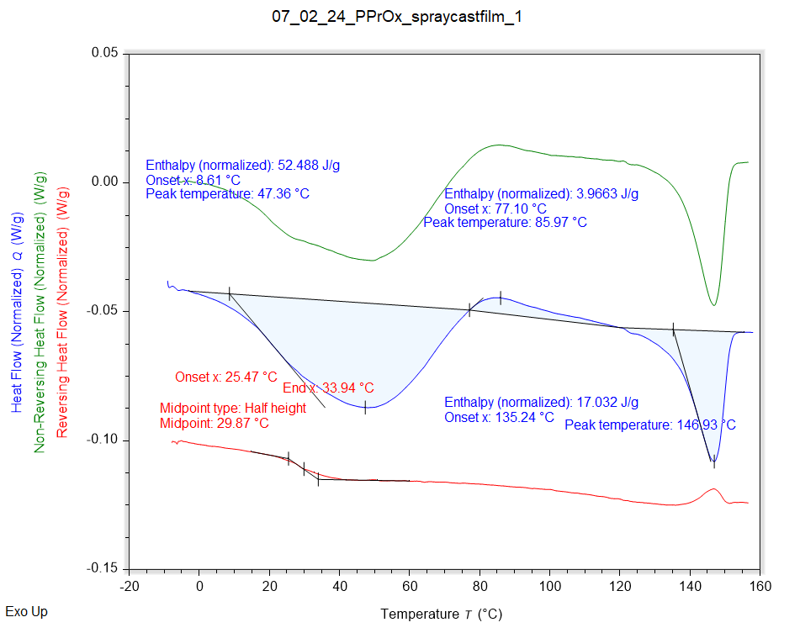

|  |  |  |  |
| --- | --- | --- | --- |
| Solvent HC1 | Peak Onset | Peak Location | Enthalpy |
|  | 8.610 °C | 47.357 °C | 52.488 J/g |

|  |  |  |
| --- | --- | --- |
| Recrystallisation HC1 | Peak Onset | Peak Location |
|  | 77.097 °C | 85.974 °C |

|  |  |  |  |
| --- | --- | --- | --- |
| Melting HC1 | Peak Onset | Peak Location | Enthalpy |
|  | 135.235 °C | 146.927 °C | 17.032 J/g |

|  |  |
| --- | --- |
| Tg HC1 | Onset |
|  | 25.475 °C |